MAVEN WEB PROJECT DEPLOYMENT IN THE AWS CLOUD USING EC2 INSTANCE

Start the lab

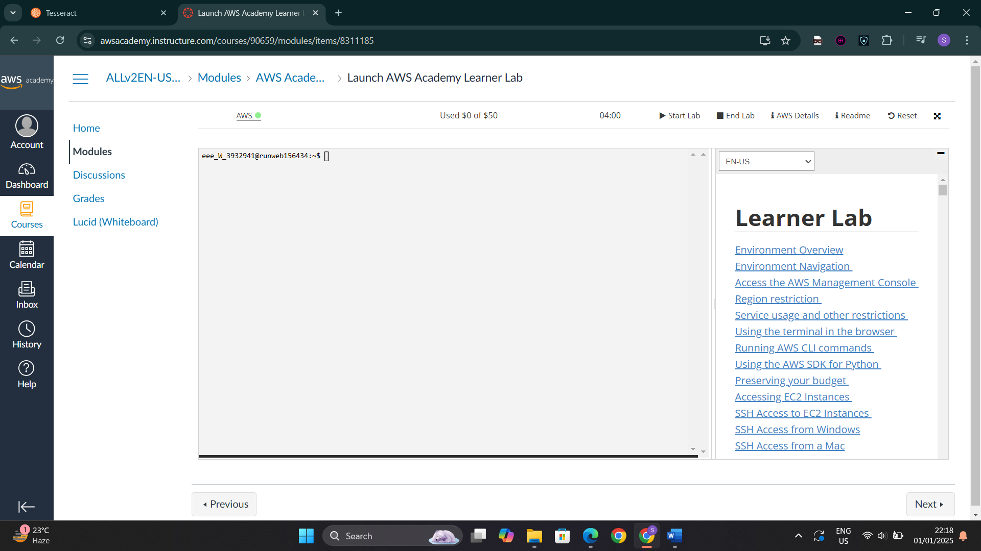

Launch the EC2 instance

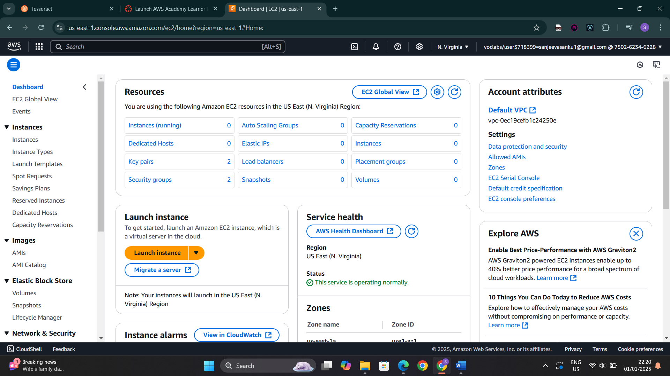

Name and select Ubuntu free tier

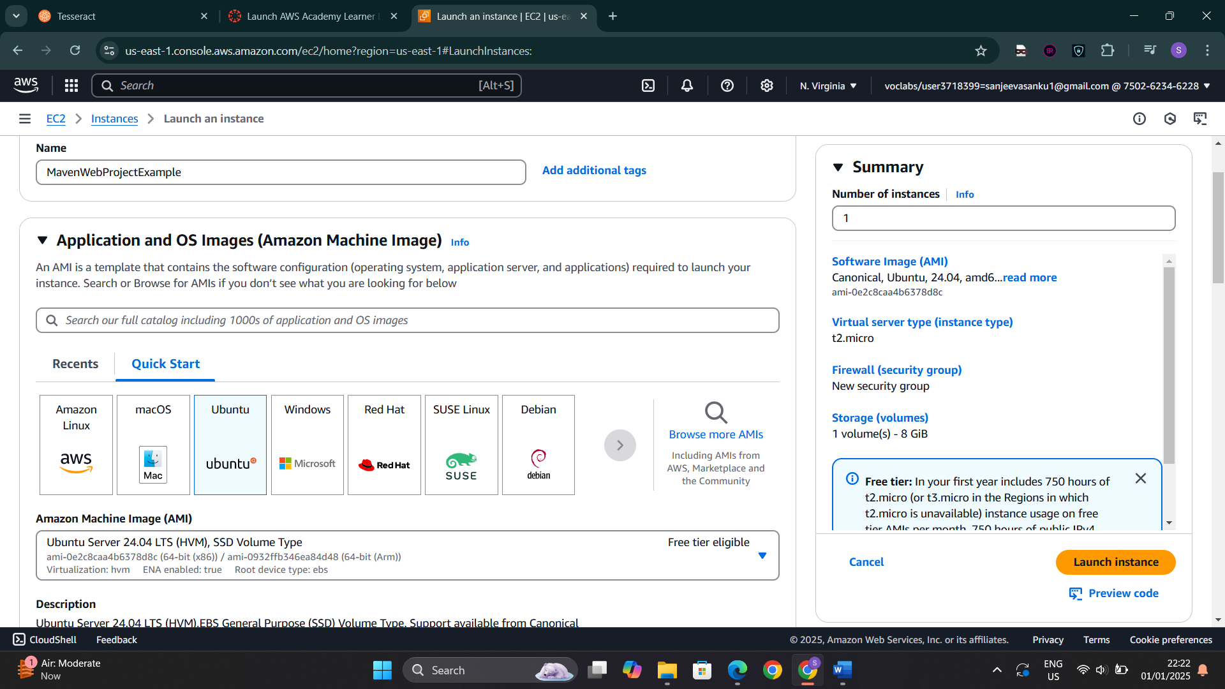

Create a new key pair

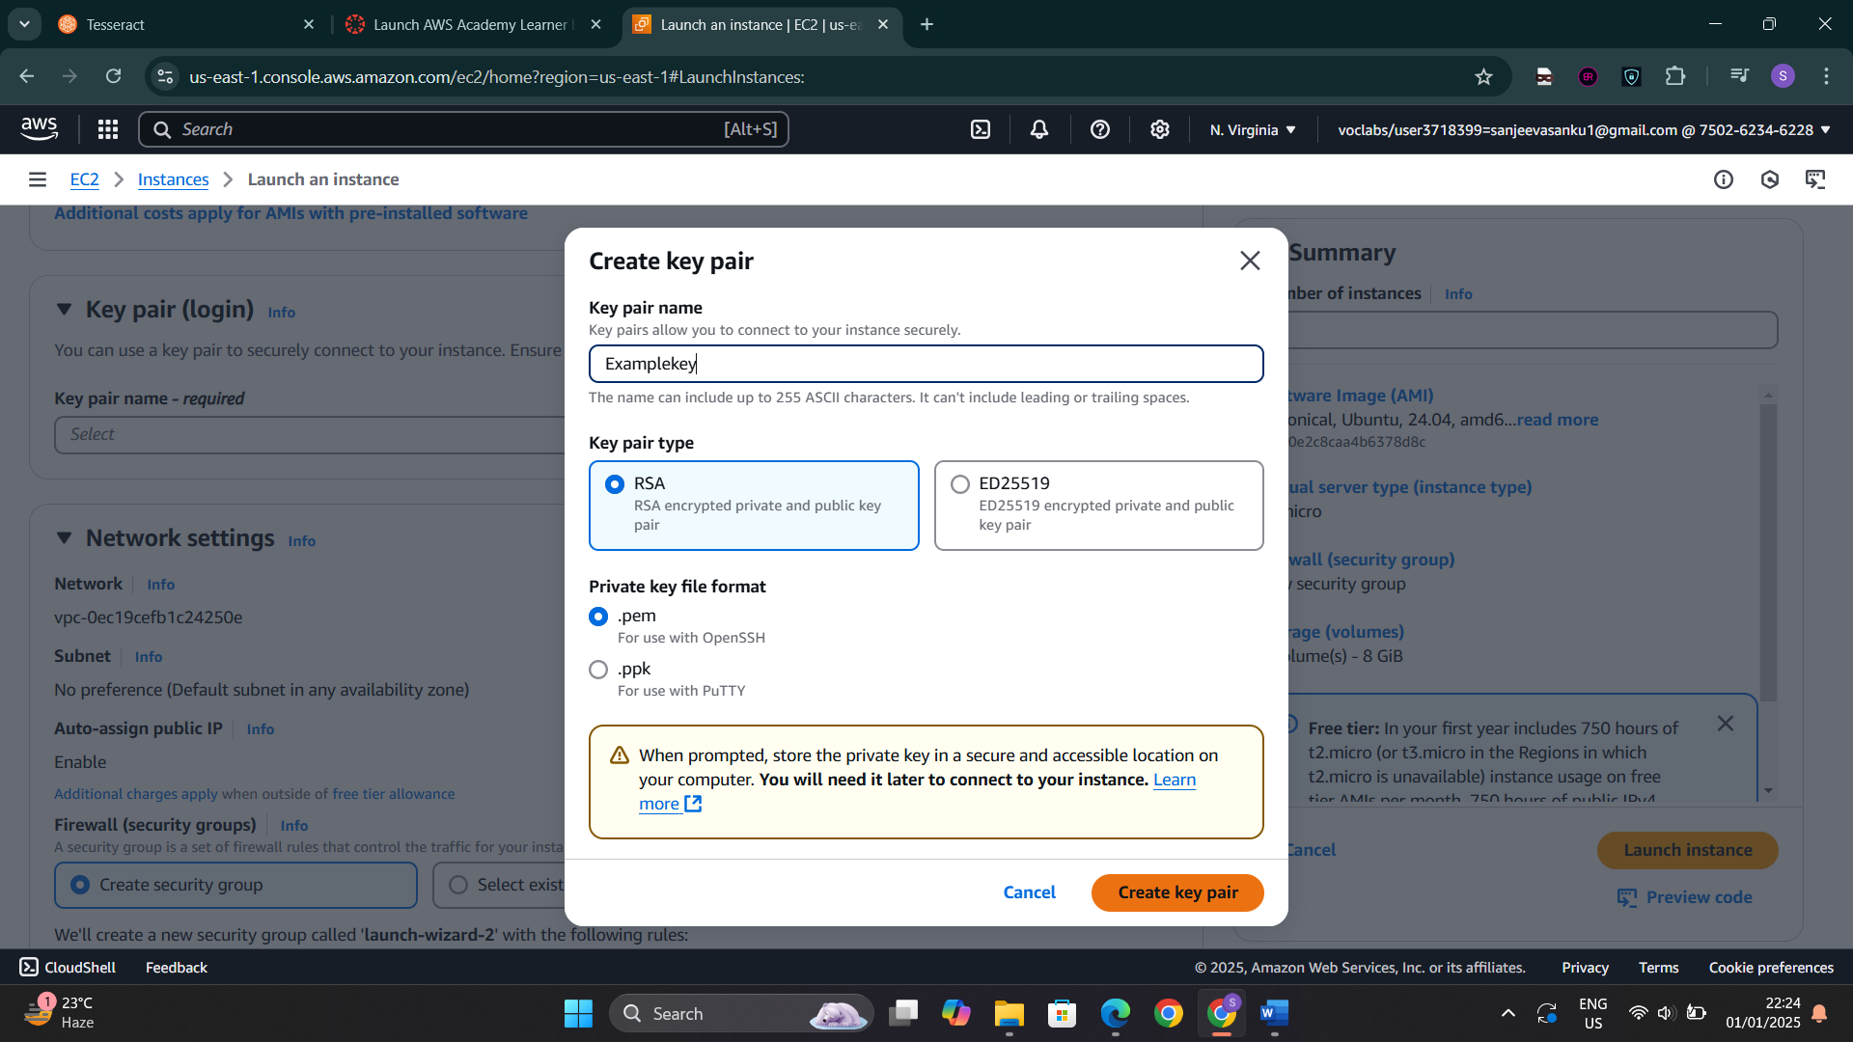

Allow HTTPS and HTTP in network and launch the instance

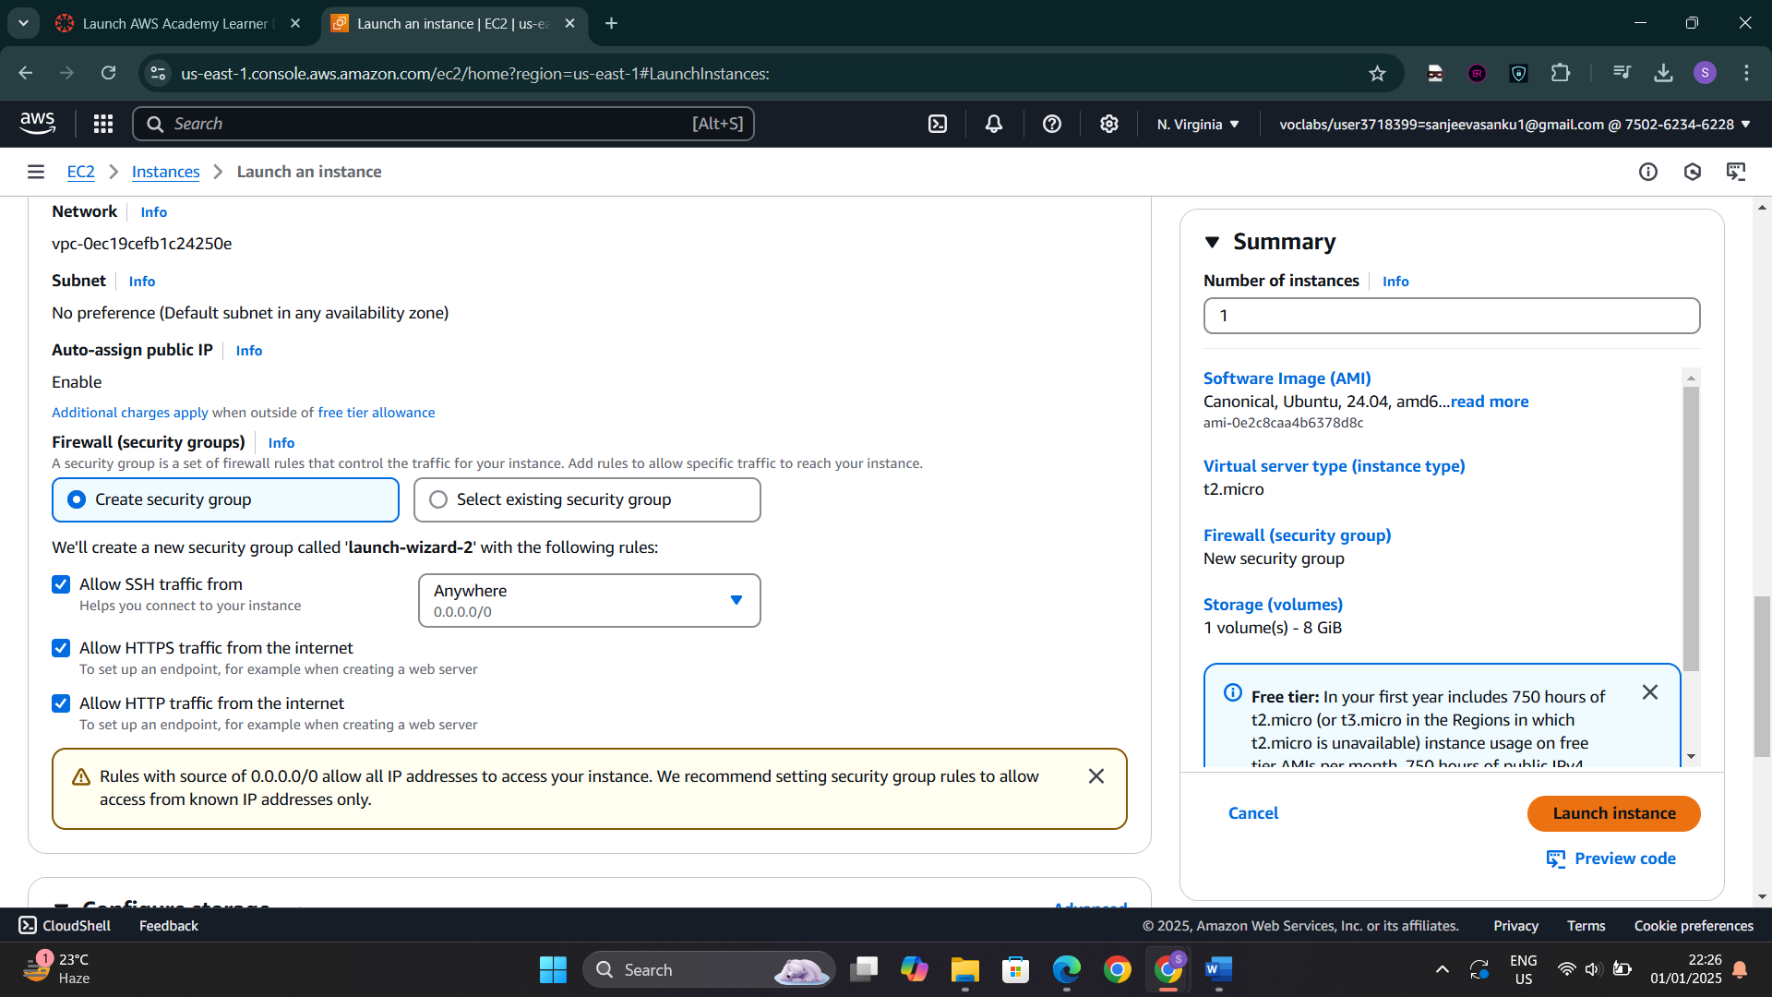

Connect to the instance

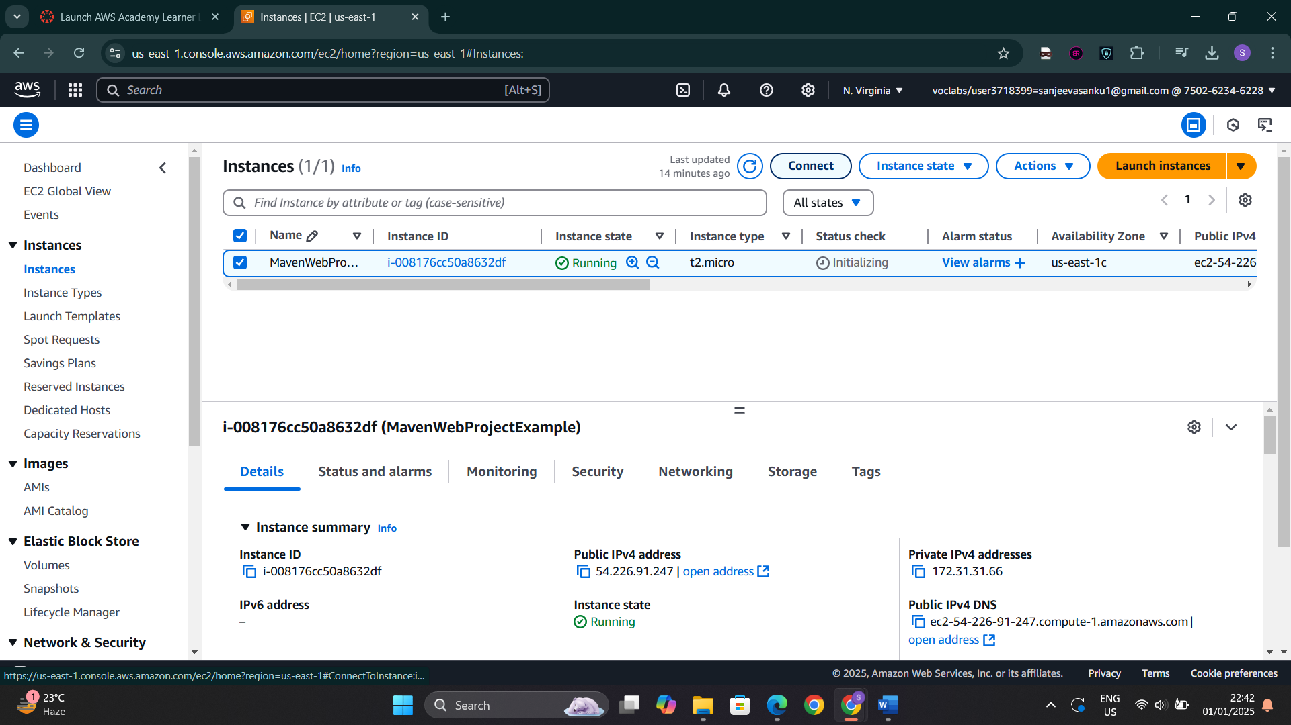

Copy the command in SSH client

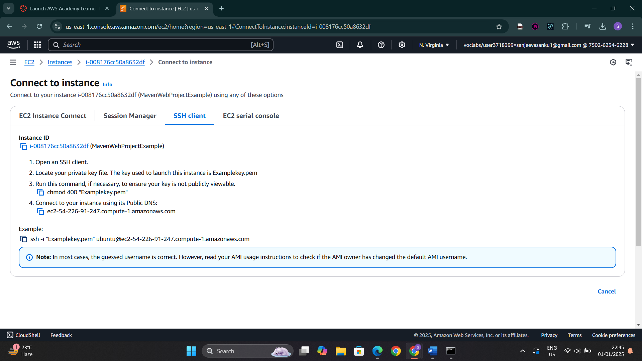

Navigate to the directory when the key is present and paste the command then do sudo apt update

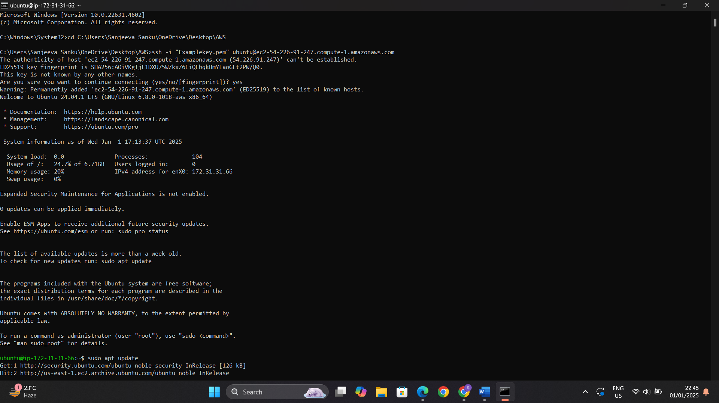

Install docker, git and nano

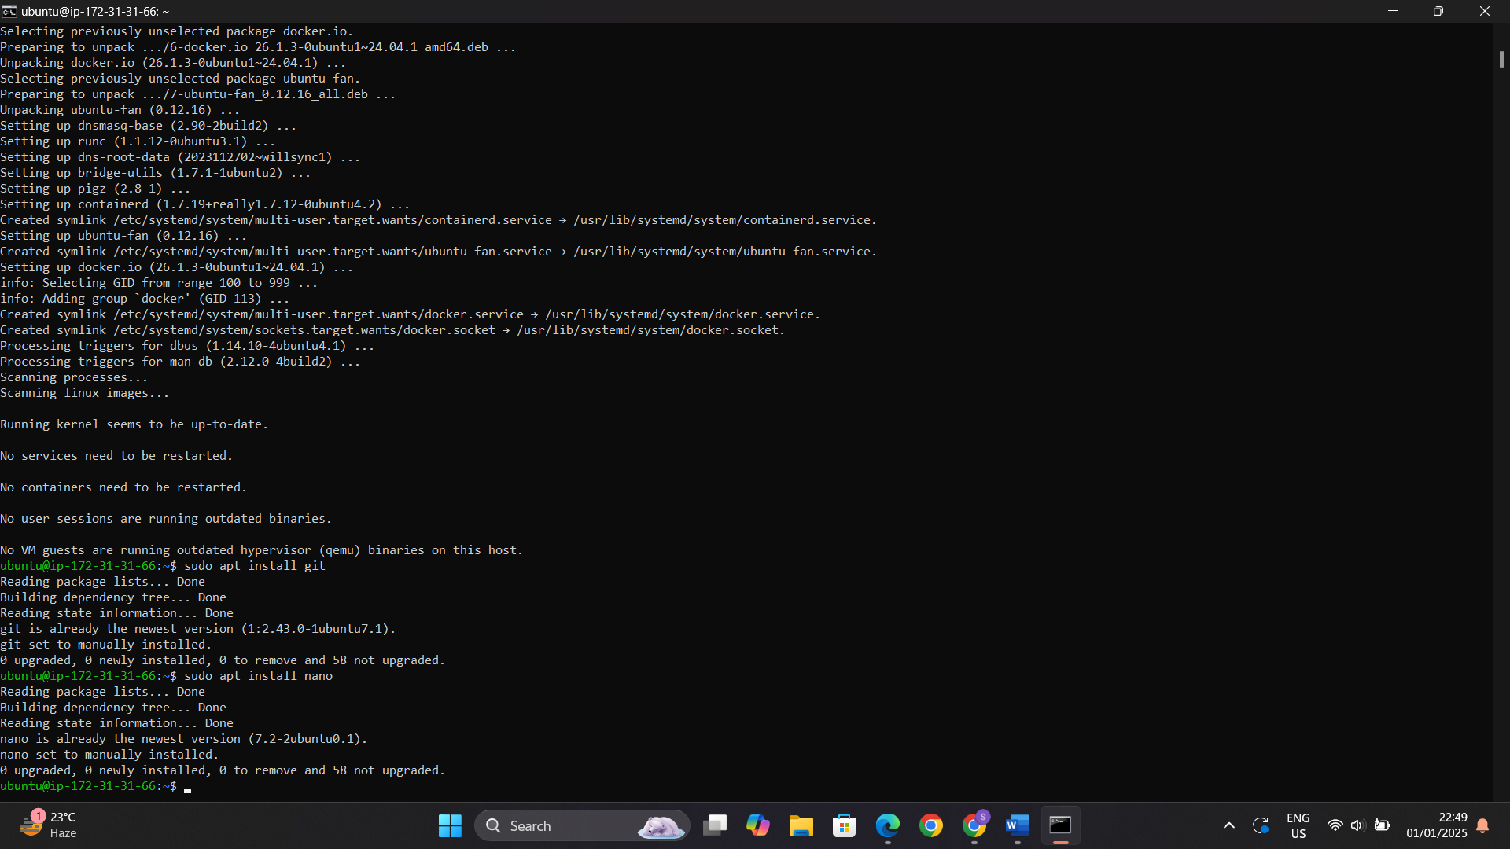

Copy the HTTP link of project

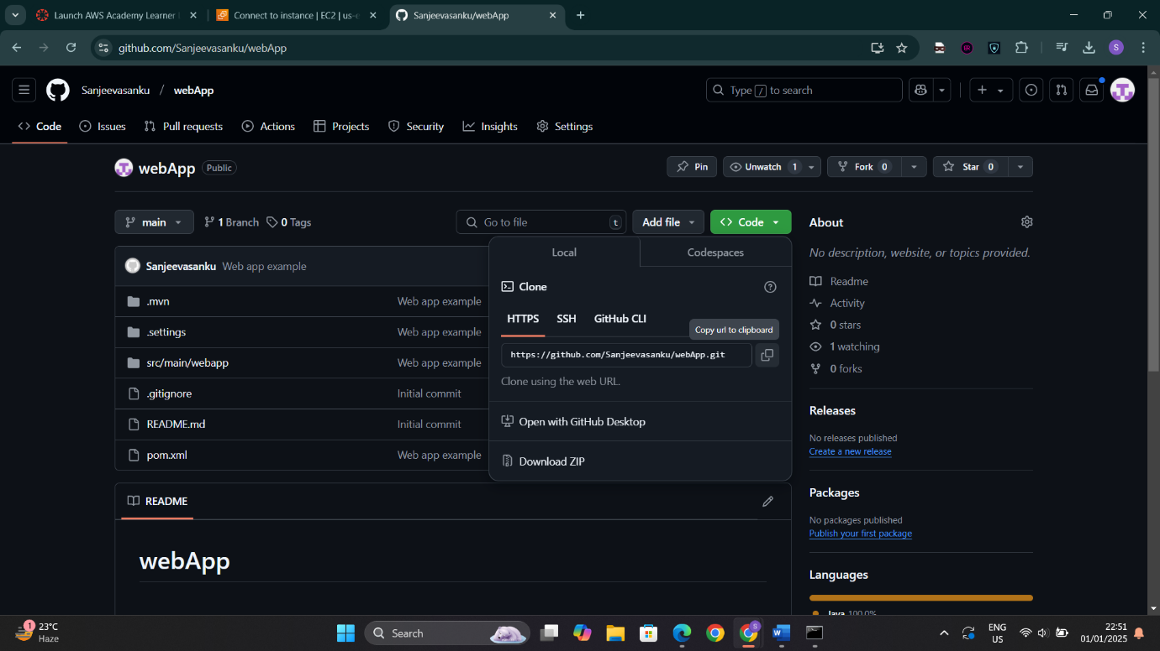

Clone the repository and navigate into the directory to create a dockerfile

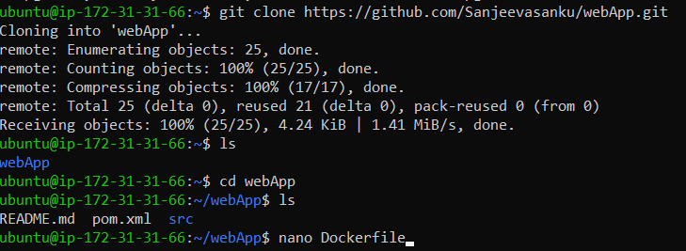

Build and run the project

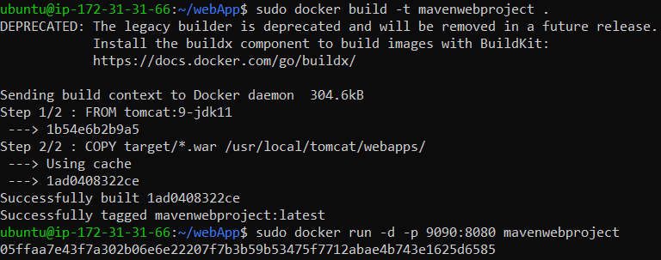

Checking inbound rules in security

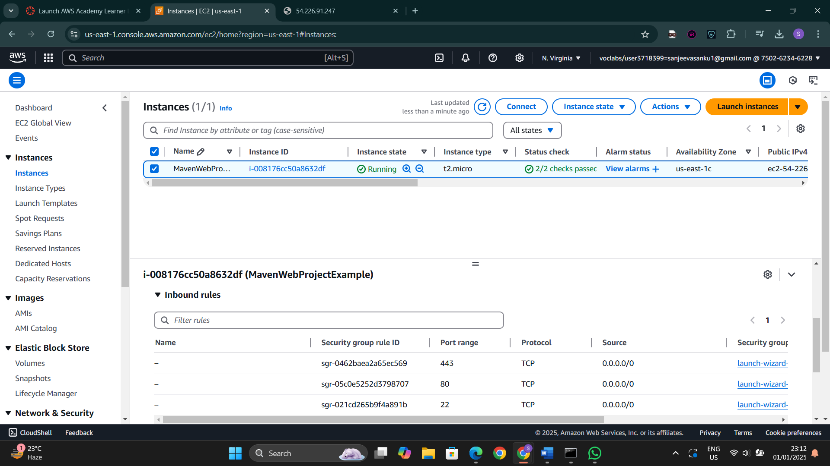

Edit inbound rules and add the port 9090

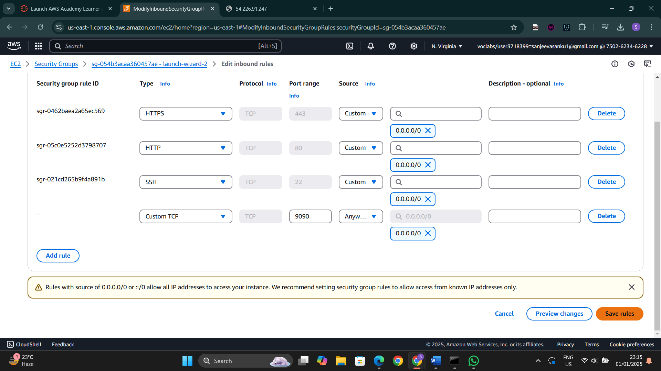

Open the public ipv4 address in new tab and add the port number and folder

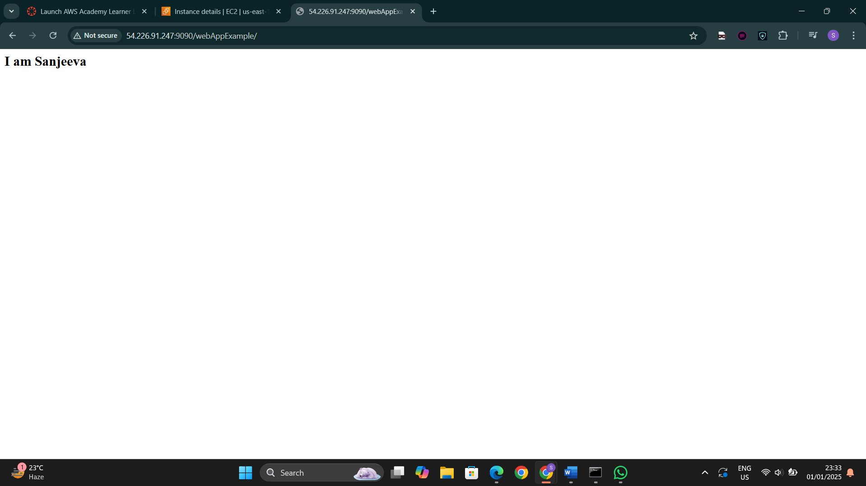

Stop the container and exit

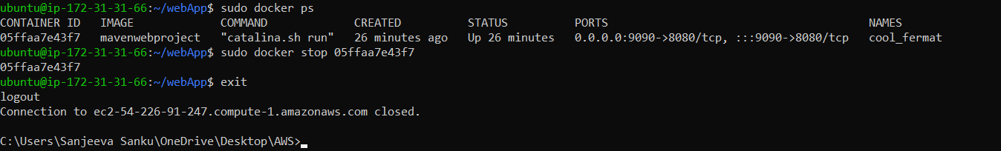

Terminate the instance

